**Step 1: Write the Lambda Function**

1. **Sign in to AWS Console:**
   * Go to the [AWS Management Console](https://aws.amazon.com/console/) and search for **Lambda**.

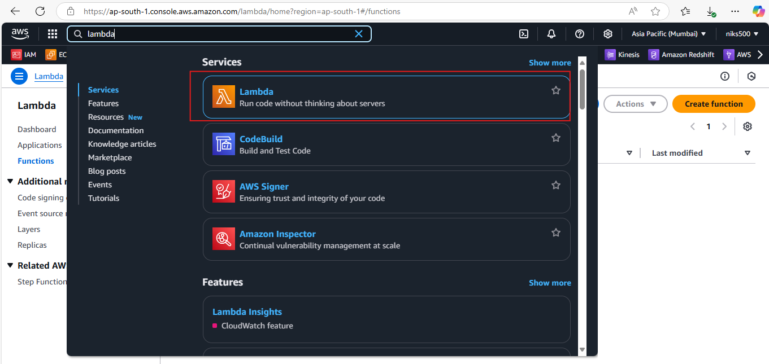

1. **Create a Lambda Function:**
   * In the **AWS Lambda Console**, click **Create function**.

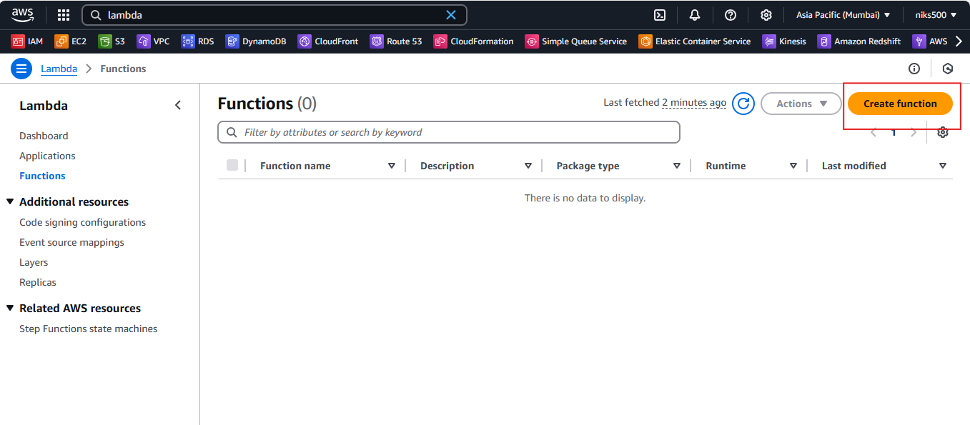

* + Choose **Author from scratch**.
  + Enter a function name, for example, MyFirstLambda.
  + Select a **runtime** based on the language you want to use. For example, you can use **Python 3.8** or **Node.js 14.x**.
  + Under **Permissions**, you can either choose **Create a new role** or select an **existing role** that has necessary permissions.

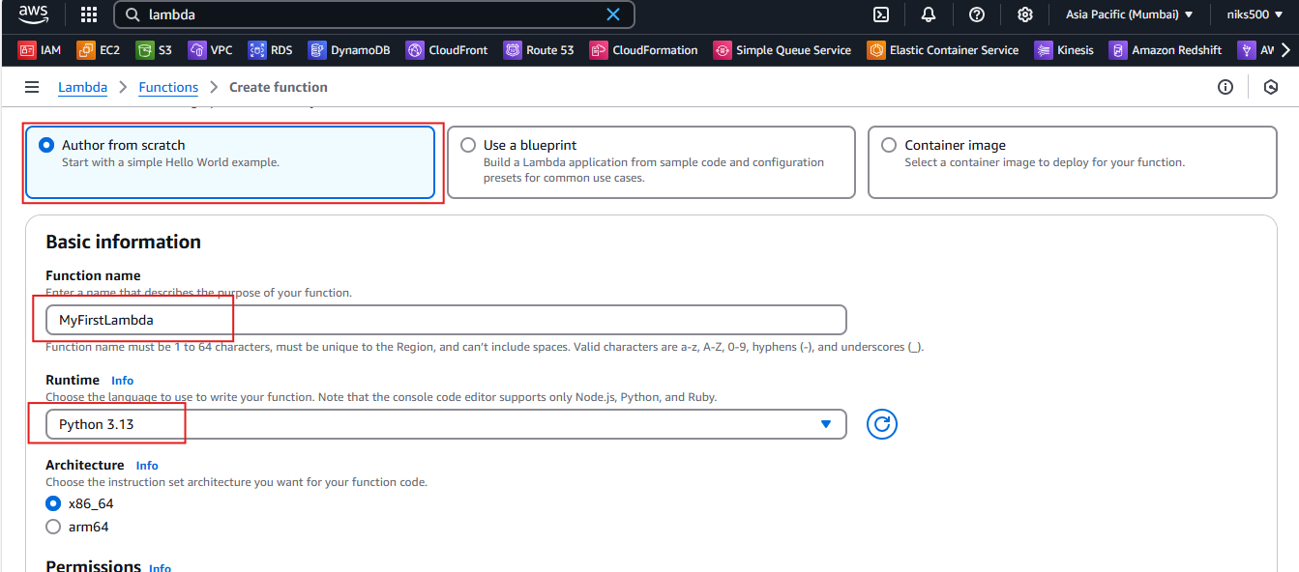

1. **Write Your Lambda Function:**
   * In the inline editor that appears, write your function code. For example, here’s a simple Python function that prints "Hello, World!" when triggered:

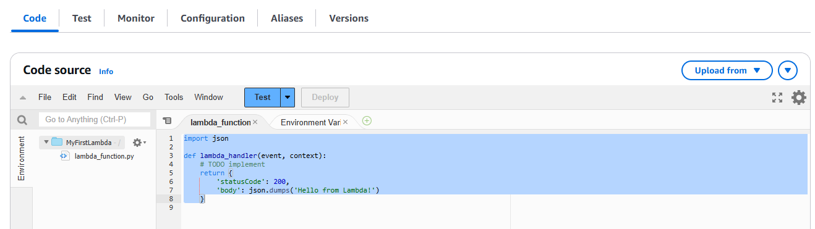

**Step 2: Triggering the Lambda Function**

You can trigger your Lambda function in multiple ways, depending on the use case. Common event sources include **API Gateway**, **S3**, **SNS**, **CloudWatch Events**, etc.

**Triggering Lambda Using API Gateway**

1. **Create an API Gateway:**
   * Go to the **API Gateway Console** in the AWS Management Console.

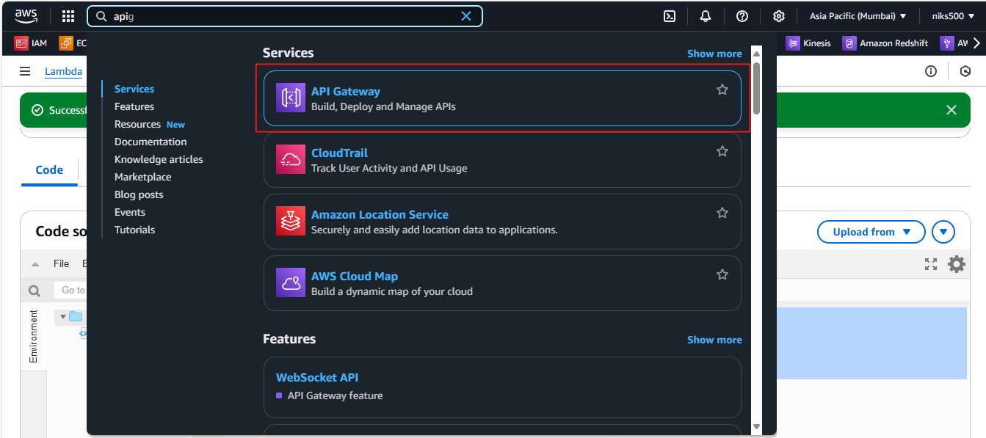

* + Click **Create API** and choose **HTTP API** or **REST API**.

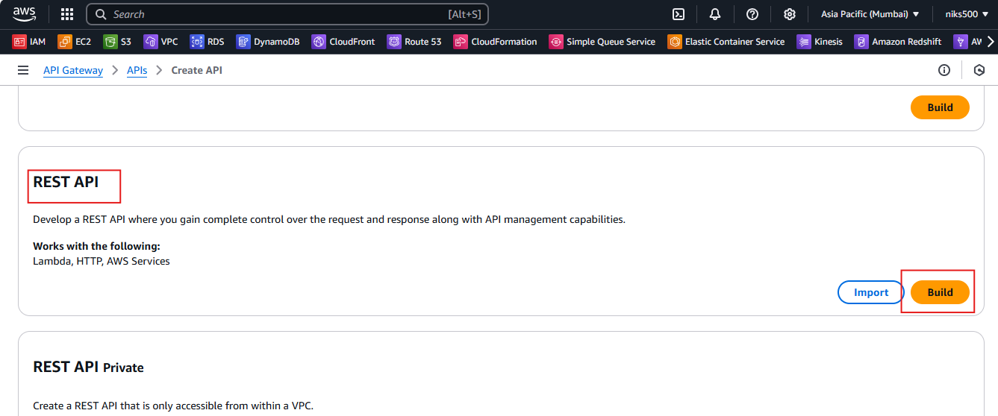

1. **Configure the API to Trigger Lambda:**
   * Once the API is created, you need to link it with your Lambda function.

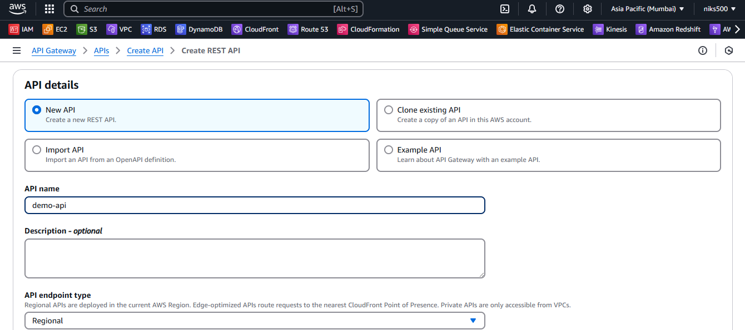

* + Under **Integrations**, choose **Lambda Function** and select the function you created (e.g., MyFirstLambda).
  + Set the **Method** to ANY (to trigger the Lambda with any HTTP request method).

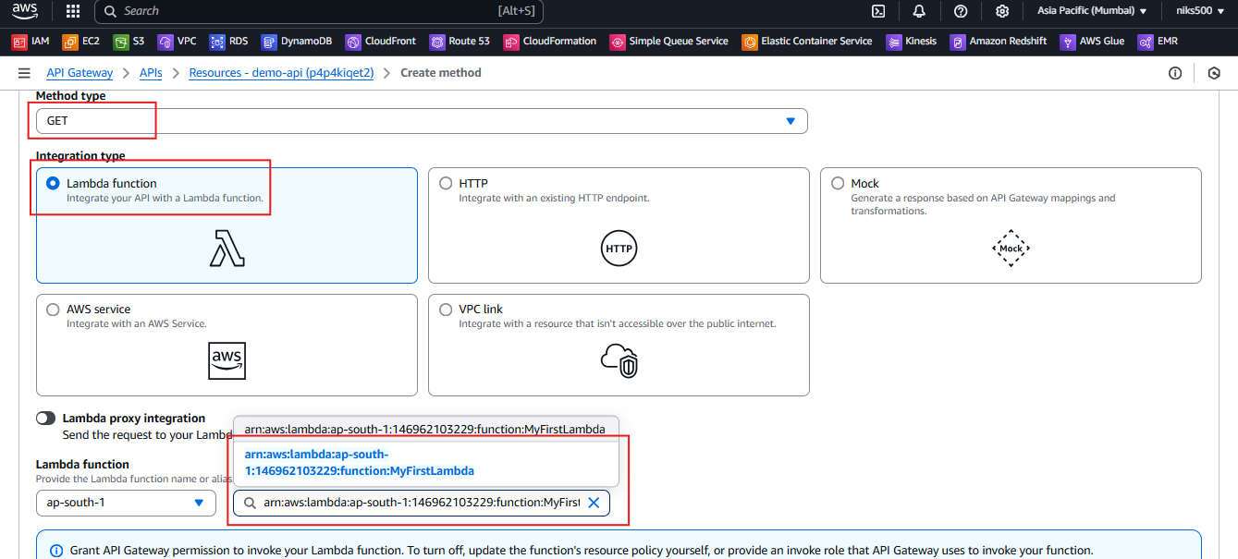

1. **Deploy API:**
   * Once the API is created, you will need to deploy it to make it available. Create a new stage (e.g., prod).

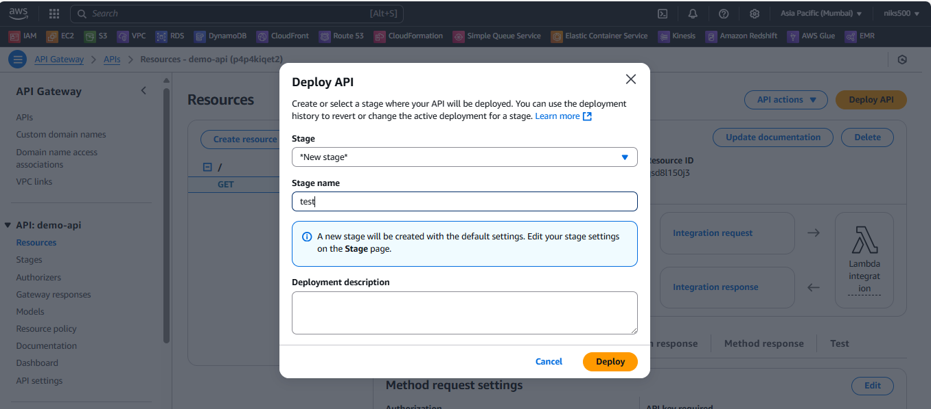

1. **Test the API:**
   * After deployment, you’ll get an **Invoke URL**.

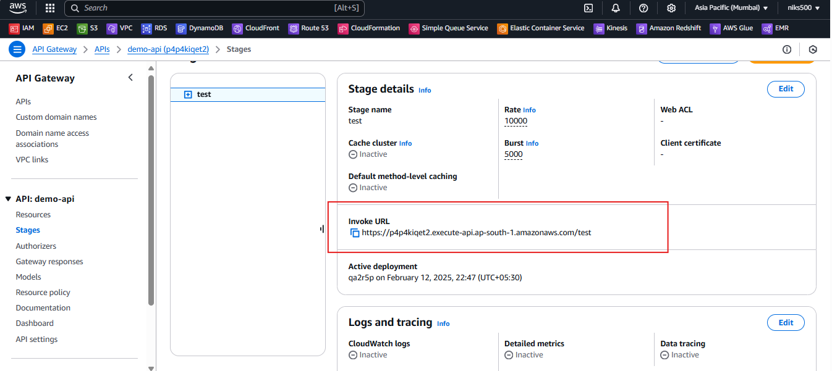

* + You can trigger your Lambda by making an HTTP request to the **Invoke URL**.

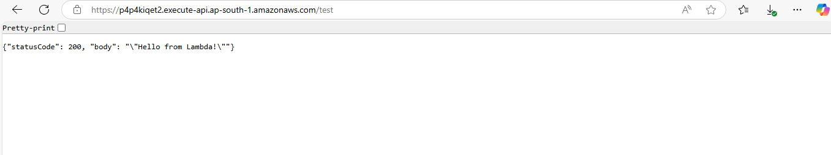

**Step 3: Check Lambda Execution Logs**

Lambda provides **logs** for each invocation in **Amazon CloudWatch**.

1. **Go to CloudWatch Console**:
   * In the **AWS Console**, search for **CloudWatch**.
   * Under **Log Groups**, find the log group associated with your Lambda function (it will be in the format /aws/lambda/MyFirstLambda).
2. **View Logs**:
   * Select the log group, and click on the most recent log stream.
   * Here you’ll see logs for each invocation, including any print statements or returned values.